**Advanced Placement Literature & Composition**

**Literary Criticism LENs Project**

**Rationale:**

Our study of literary criticism is helping us to learn that there are many different ways to read and respond to literary work. We have studied only 10 criticisms; there are many others.

**Assignment:**

For this assessment, you will choose two different critical theories to explore. For each, you will look through that “lens” and show what you see. You may choose any text (of literary merit) which you know well. You may choose short stories or novels.

**Product:**

Create a visual representation of what you see, using glasses as your vehicle or metaphor. You may re-create the glasses and create a poster, or you may produce some other product, as long as you provide the necessary components.

**Content:**

In your project, provide the following:

1. background (text, author, genre, publication date, etc)
2. Definition of your chosen critical theory, *in your own words*
3. Details from the text that are significant to that theory
4. Significance of details in relation to your theory. So what?

**Due Date : ­­­­­ ___________**

[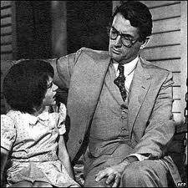](http://www.google.com/imgres?hl=en&safe=active&tbo=d&biw=1440&bih=732&tbm=isch&tbnid=1MjZv8nWORL8sM:&imgrefurl=http://www.fanpop.com/clubs/the-fanfic/images/27079699/title/kill-mockingbird-photo&docid=XUeciMh382v70M&imgurl=http://images5.fanpop.com/image/photos/27000000/To-Kill-A-Mockingbird-the-fanfic-27079699-300-300.jpg&w=300&h=300&ei=xALBUNLKCJKXqwGv6IGoBA&zoom=1&iact=hc&vpx=837&vpy=77&dur=417&hovh=225&hovw=225&tx=121&ty=136&sig=110069417836209732562&page=1&tbnh=132&tbnw=132&start=0&ndsp=35&ved=1t:429,r:24,s:0,i:158)[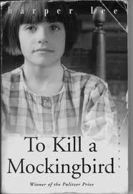](http://www.google.com/imgres?hl=en&safe=active&tbo=d&biw=1440&bih=732&tbm=isch&tbnid=w0n7dN4SjEdraM:&imgrefurl=http://www.fanpop.com/clubs/the-fanfic/images/27079702/title/kill-mockingbird&docid=VG_XdHnRp99cFM&imgurl=http://images5.fanpop.com/image/photos/27000000/To-Kill-A-Mockingbird-the-fanfic-27079702-345-500.jpg&w=345&h=500&ei=xALBUNLKCJKXqwGv6IGoBA&zoom=1&iact=hc&vpx=981&vpy=329&dur=402&hovh=270&hovw=186&tx=117&ty=155&sig=110069417836209732562&page=1&tbnh=132&tbnw=94&start=0&ndsp=35&ved=1t:429,r:25,s:0,i:161)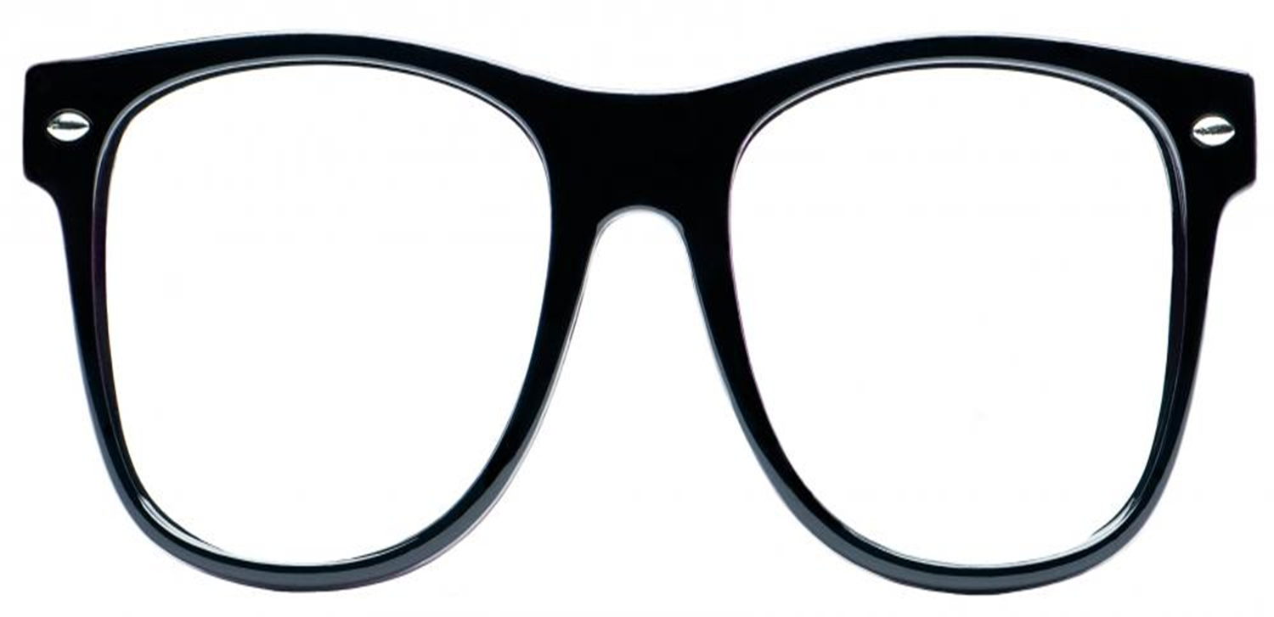

***To Kill a Mockingbird***

**Harper Lee**

**Published:** 1960

**Genre:** Post-Modern

**Era:** Published during Civil Rights Era, set during Great Depression.

**Critical Theory:** Feminism

**Feminism:** *Define in your OWN words*

**“Pass the damn ham, please.”**

* Scout has no mother and has no memory of her.
* Scout has no model for how to behave as a “lady” and therefor is not shielded to the harsh realities of her world.